Creating Futures

INTERNATIONAL STUDENT PROGRAM

ORIENTATION HANDBOOK

2021

This handbook will provide you with a convenient resource. Complete the sections with International Student Coordinator and keep this for future reference.

Academic Programs at Sunshine College
Sunshine College is a multicultural and Co-educational College located in the inner west of Melbourne, Victoria. We are a multi-campus college with two sites.
Together the sites service approximately 1000 students from a wide range of ethnic backgrounds. The curriculum that is offered meets the requirements of the Victorian and Federal Governments and is similar to that offered in all Victorian schools. What is different about Sunshine College is the way our curriculum is delivered. Our programs in Literacy, Mathematics and in Pathways have received National recognition for their quality. We also take great pride in our welfare support of all students at all levels.
Our Campuses are located in the centre of Sunshine close to a major bus and train station. Sunshine is an area that is becoming a major hub of development in the inner west of Melbourne. Our West Campus offers the Victorian Certificate of Education Certificate (VCE), with a strong emphasis on academic success. In conjunction with the Victorian Certificate of Education, students may include Vocational Education and Training (VET) in their VCE. The VET subject provides students with credit towards their VCE. All programs are delivered within our college.

All of our staff have a high level of expertise in the delivery of all of our programs.

General Health Care, Personal Safety and Legal Rights and Responsibilities
Our college has a pastoral care program across all levels. This program is driven by welfare and student services coordinators. The whole college program is coordinated by a college welfare coordinator.
As part of the orientation program students are taken through material from two booklets:
- Street smart handbook – see www.smarthandbooks.com.au
- Right A Wrong – prepared by Victoria Legal Aid : see www.legalaid.vic.gov.au
(This booklet has been translated into Vietnamese and Chinese).
- The following websites are also used: http://www.studymelbourne.vic.gov.au/help-and-advice/the-law-and-your-rights https://aei.gov.au/Regulatory-Information/Pages/Regulatoryinformation.aspx

The differences between the “way things are done” in Vietnam and China are emphasised. Every country has its own ways of solving life problems. The Program Coordinator and our two Vietnamese aides offer ongoing personal support to all International students.

Creating Futures

INTERNATIONAL STUDENT FILE COVERSHEET

Student ID Number
IS ID Number
Family Name
First Name
DOB
Date of Arrived in Australia
Passport Number
Passport Expiry Date
Visa Number
Visa Type
Visa Expiry Date
Overseas Student Health Cover Member No Contact tel 132331 + 618622 5780 (outside Au) Email Medibank ask_us@medibank.com.au
English Language Centre
Expected Commencement Date
Actual Start Date
Expected Completion Date
Actual Completion Date
Father’s Name Mother’s Name
Parents Overseas Address
Parents Overseas Phone/ Fax
Parents Email Address
Homestay Provider / Third Party / Department of Home Affairs Approved relative Name
Homestay Provider/ Third Party/ Department of Home Affairs Approved Relative Address
Department of Home Affairs Approved Relative Homestay Provider/ Third Party/ Phone/ Fax/ Mobile
Homestay Provider/ Third Party/ Department of Home Affairs Approved Relative Mail Address
Student Email Address
Student Mobil
Refering Agent

SUNSHINE COLLEGE is a multi-campus College comprising four school sites.

College Principal MR. TIM BLUNT

School’s Telephone 8311 5200

Email: sunshine.co@edumail.vic.gov.au

Two campuses at West Sunshine and Sunshine North – Catering for Year 7 to Year 12.

West CAMPUS Year 7 to 12
25 Lachlan Road, Sunshine West 3020
Assistant Principal MS. MONA RAGHDO (Student Engagement, Community & Operations)
Assistant Principal Ms. Jodie Parsons (Curriculum Innovation & Excellence)
Assistant Principal Ms. Yvonne Reilley (Strategy & Accountability)

NORTH CAMPUS Year 7 to Year 10
Northumberland Road, Sunshine North, 3020
Assistant Principal Mr. Ewen Burt (Student Engagement, Community & Operations)

INTERNATIONAL STUDENT CO-ORDINATOR
Mr. Preet Sachdeva

INTERNATIONAL STUDENT Assistants
Mr. Kiet Quach &
Ms. Anh Lee

Mr. Graham Newman (International Student Program Consultant)

DIRECTIONS & LOCAL AREA
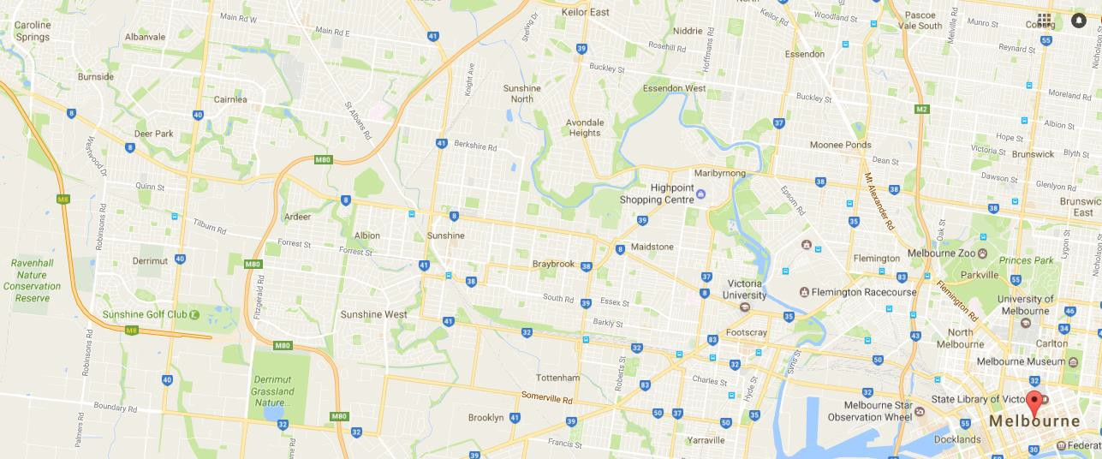

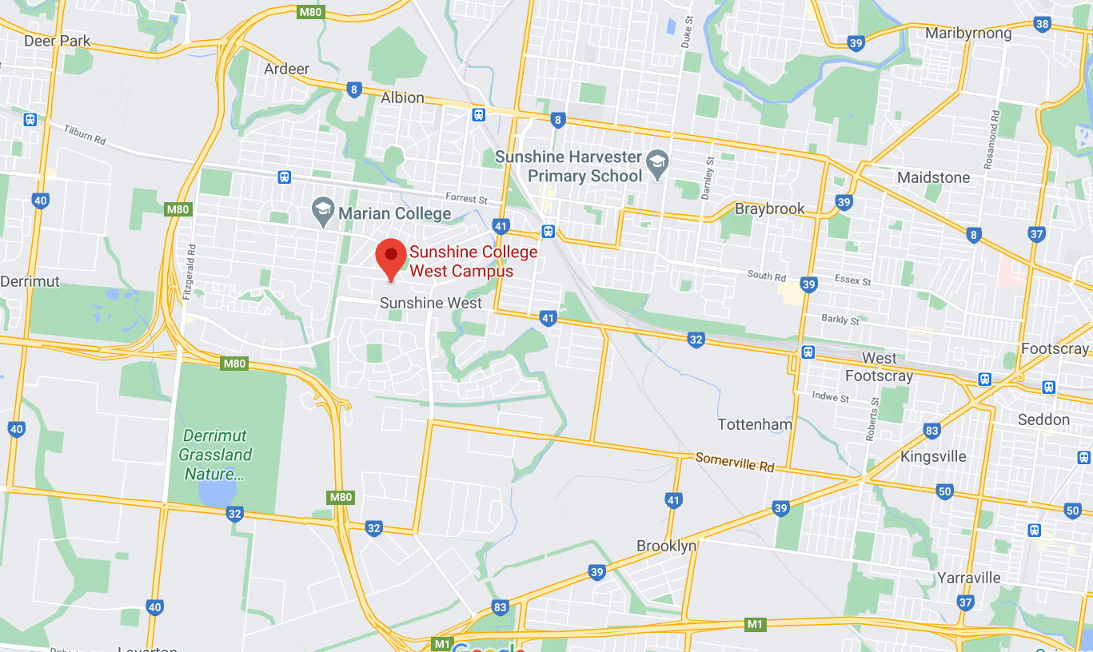

TRAVEL & TRANSPORT SYSTEMS

Public Transport near Sunshine College

West Campus
North Campus

FARES Zone 1

International Students can use concession fares

Travel from Homestay to College
Zone 2

Travel from College to City

Melbourne Public Transport Web site http://www.metlinkmelbourne.com.au /
On this website home page you can find the JOURNEY PLANNER, which guide you to reach your destination by public transport.

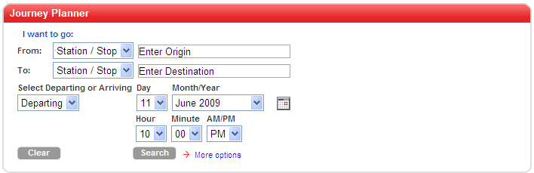

MELBOURNE TRAIN NETWORK
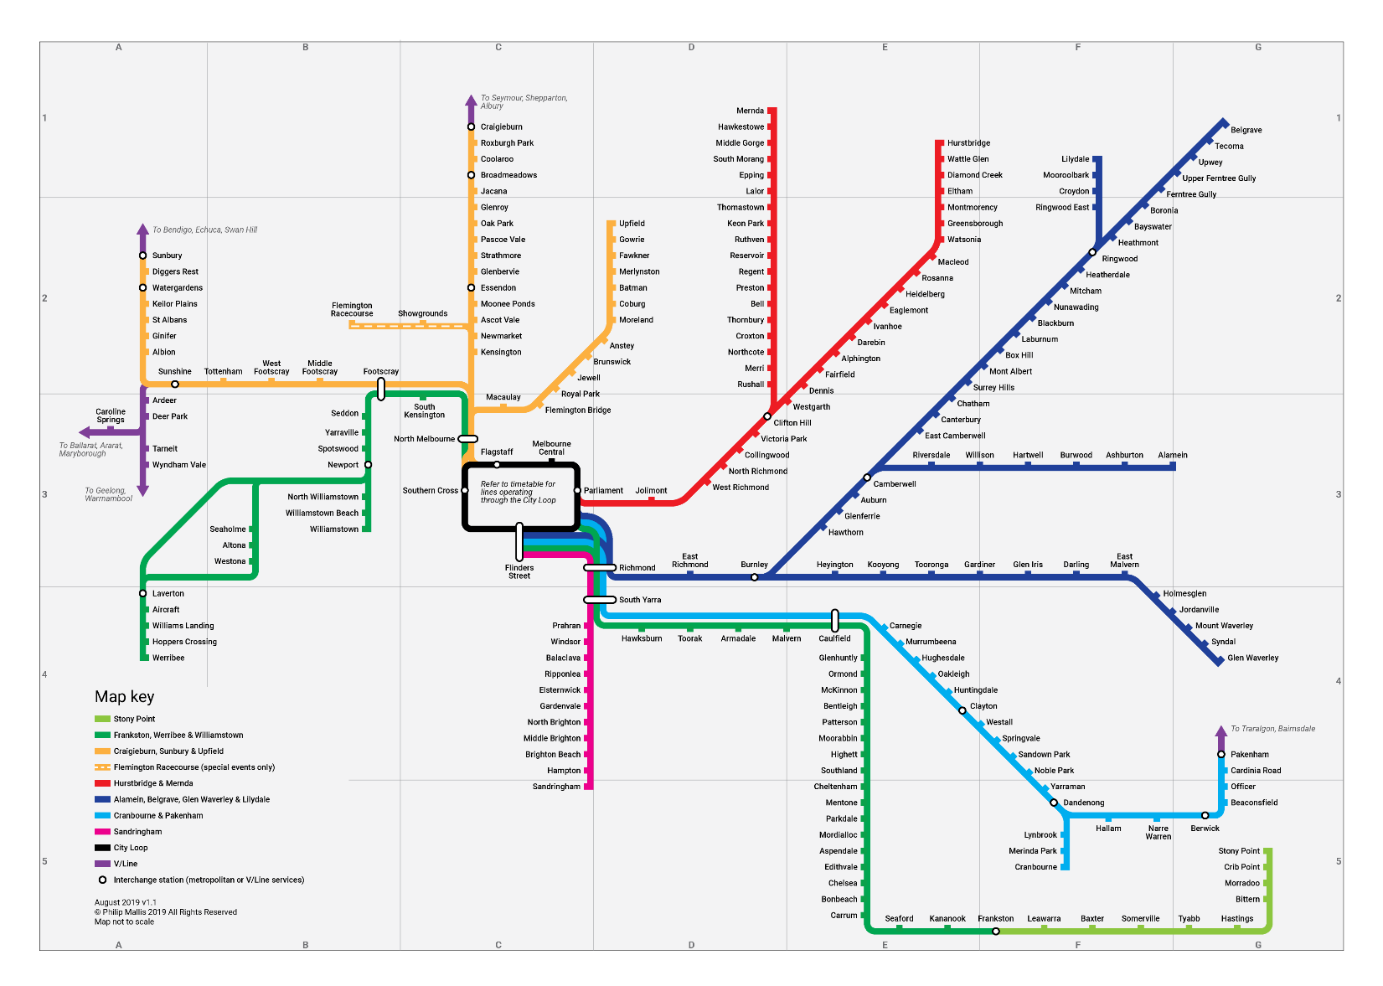
Public transport information is available in different languages. Call the number next to the language in the table below:

Arabic (03) 9321 5440 | Mandarin (03) 9321 5454
Cantonese (03) 9321 5441 | Somali (03) 9321 5446
Croatian (03) 9321 5442 | Spanish (03) 9321 5447
Dinka (03) 9321 5452 | Sudanese Arabic (03) 9321 5453
Greek (03) 9321 5443 | Turkish (03) 9321 5448
Italian (03) 9321 5444 | Vietnamese (03) 9321 5449
Macedonian (03) 9321 5445 | All other languages (03) 9321 5450

MELBOURNE TRAM NETWORK
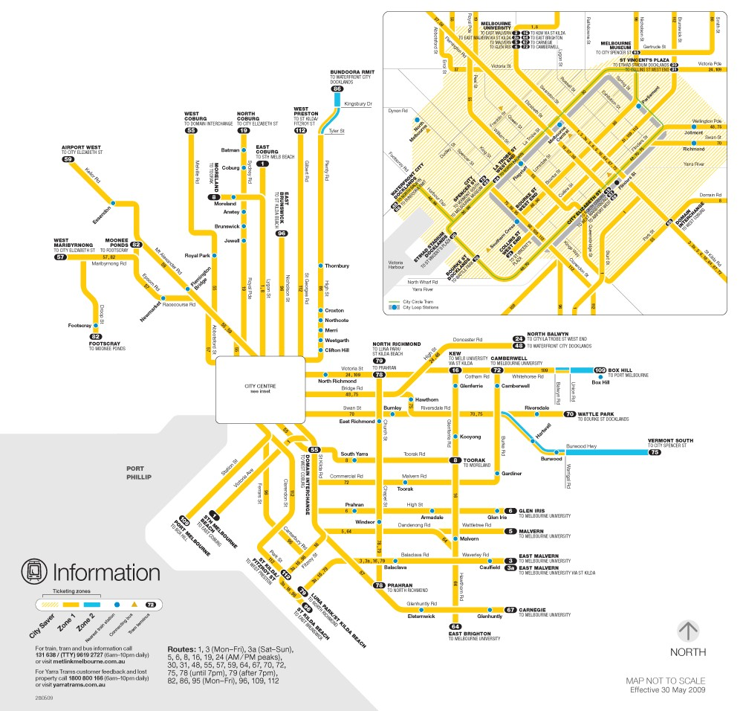

AUSTRALIA

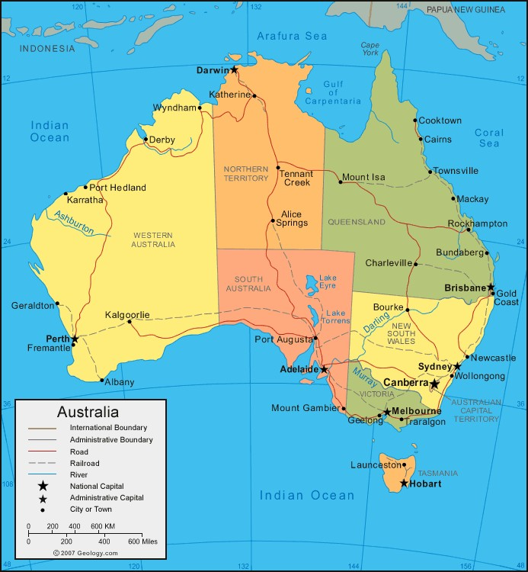

AUSTRALIAN CUSTOMS AND CULTURE

Greetings

Weekend Activities

Diet

Outdoors & the beach

Sports

FESTIVALS
New Year Eve &New Year Australian Day Labor Day Anzac Day Mother’s Day

Queen’s Birthday Father Day Melbourne Cup Day

Christmas Day

EDUCATION IN AUSTRALIA
Important differences
- Asking questions
- Requesting help from teacher
- Independent/ individual study
- Homework & Study routine
- Research
- Excursion/Camp
- Careers Counselor
- Student Welfare Officer
- Student Service Leaders
- Coordinators

SUNSHINE COLLEGE.
Student Diary
Study program – Enter your subjects here:

COLLEGE DIARY
Important dates – Refer to the list of important dates given to all student/ guardians/ welfare supporters and host families
EMERGENCY CONTACTS

Telephone 000
Ambulance Fire
Police
Welfare Support/ Guardian

International Student Coordinator

SUNSHINE COLLEGE

Tel (+613) 8311 5200
Fascimile (+613)
Homestay

TELEPHONE & COMPUTERS

International calling

Mobile phones

Pre-paid& Contracts

Internet costs
Sharing/ Individual

My email address@sunshine

VISA CONDITIONS SUMMARY

- PERSONAL DETAILS We must always have your correct details on file

- STUDY PROGRAM You must be engaged in a full-time study program
You must maintain satisfactory grades

- ATTENDANCE You must attend 100% of classes, and college program
activities. Your attendance is checked every lesson and
this is entered onto the computer system. The system checks your attendance every day

